Assessment

- To create the database and then create all three tables (city, customer, country) inside it, here are the exact MySQL commands you can run.
Step 1: Create the Database
CREATE DATABASE world_data;
Step 2: Use the Database
USE world_data;
Step 3: Create COUNTRY Table
- SQL – Create Table
CREATE TABLE country (
id INT PRIMARY KEY,
country_name VARCHAR(100),
country_name_eng VARCHAR(100),
country_code VARCHAR(10)
);
- SQL – Insert Data
INSERT INTO country (id, country_name, country_name_eng, country_code)
VALUES
(1, 'Deutschland', 'Germany', 'DEU'),
(2, 'Srbija', 'Serbia', 'SRB'),
(3, 'Hrvatska', 'Croatia', 'HRV'),
(4, 'United States of America', 'United States of America', 'USA'),
(5, 'Polska', 'Poland', 'POL'),
(6, 'España', 'Spain', 'ESP'),
(7, 'Rossiya', 'Russia', 'RUS');

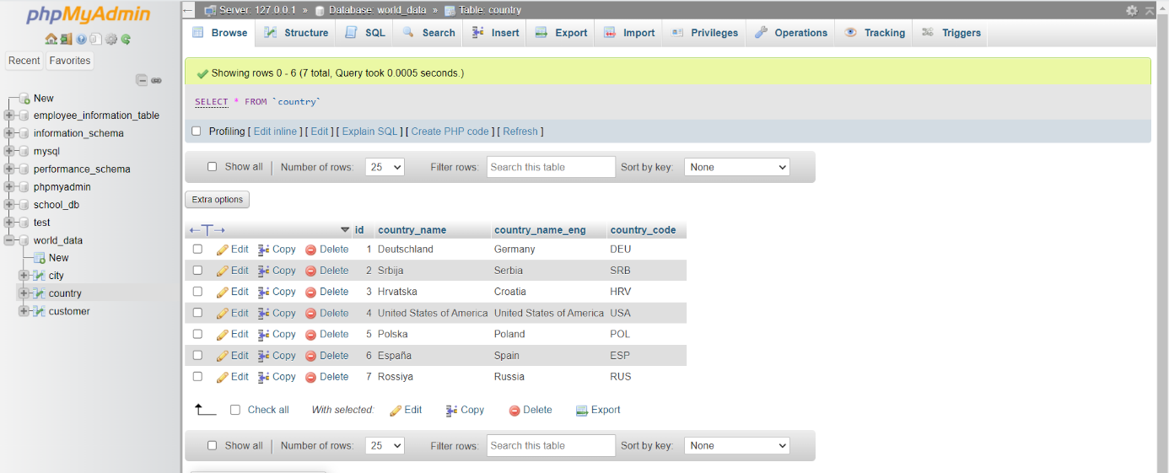
Step 4: Create CITY Table
- SQL – Create Table
CREATE TABLE city (
id INT PRIMARY KEY,
city_name VARCHAR(100),
lat DECIMAL(10,6),
longitude DECIMAL(10,6),
country_id INT,
FOREIGN KEY (country_id) REFERENCES country(id)
);

- SQL -Insert Data
INSERT INTO city (id, city_name, lat, longitude, country_id)
VALUES
(1, 'Berlin', 52.520008, 13.404954, 1),
(2, 'Belgrade', 44.787197, 20.457273, 2),
(3, 'Zagreb', 45.815399, 15.966568, 3),
(4, 'New York', 40.730610, -73.935242, 4),
(5, 'Los Angeles', 34.052235, -118.243683, 4),
(6, 'Warsaw', 52.237049, 21.017532, 5);

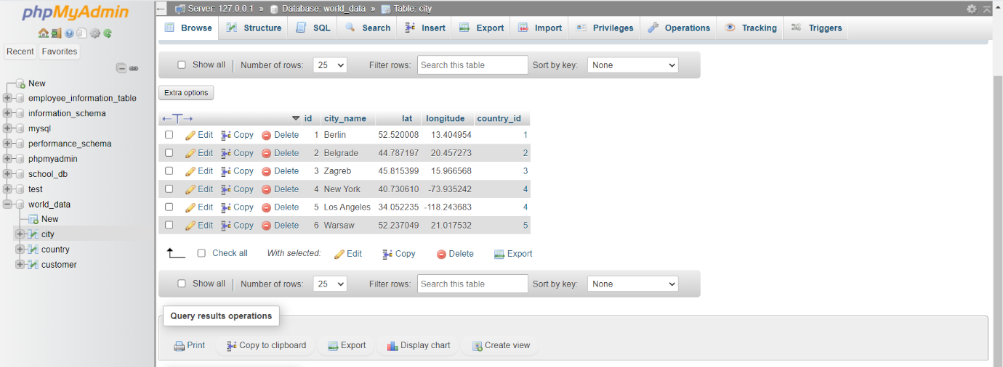

Step 5: Create CUSTOMER Table
- SQL – Create Table
CREATE TABLE customer (
id INT PRIMARY KEY,
customer_name VARCHAR(100),
city_id INT,
customer_address VARCHAR(150),
next_call_date DATE,
ts_inserted DATETIME,
FOREIGN KEY (city_id) REFERENCES city(id)
);
- SQL – Insert Data
INSERT INTO customer (id, customer_name, city_id, customer_address, next_call_date, ts_inserted)
VALUES
(1, 'Jewelry Store', 4, 'Long Street 120', '2020-01-21', '2020-01-09 14:01:20'),
(2, 'Bakery', 1, 'Kurfürstendamm 25', '2020-02-21', '2020-01-09 17:52:15'),
(3, 'Café', 1, 'Tauentzienstraße 44', '2020-01-21', '2020-01-10 08:02:49'),
(4, 'Restaurant', 3, 'Ulica Ipa 15', '2020-01-21', '2020-01-10 09:20:21');

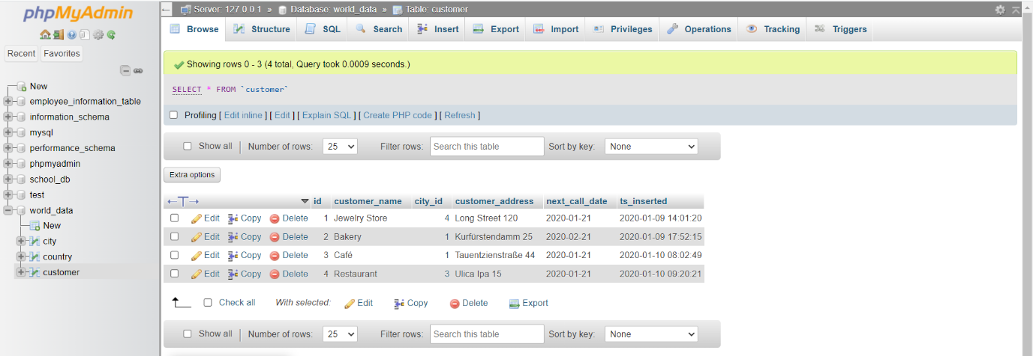

- TASK 1 — LEFT JOIN (List ALL countries + related cities + related customers)

- Requirements:
- Show ALL countries (even without cities)
- For each country → show city → show customer
- Countries with no cities (Spain, Russia) must appear
- Cities with no customers must appear
- Customers linked to cities (Berlin, Zagreb, New York)

- Query: 1
SELECT
co.country_name_eng AS country,
ci.city_name AS city,
cu.customer_name AS customer
FROM country co
LEFT JOIN city ci
ON co.id = ci.country_id
LEFT JOIN customer cu
ON ci.id = cu.city_id ORDER BY co.id;
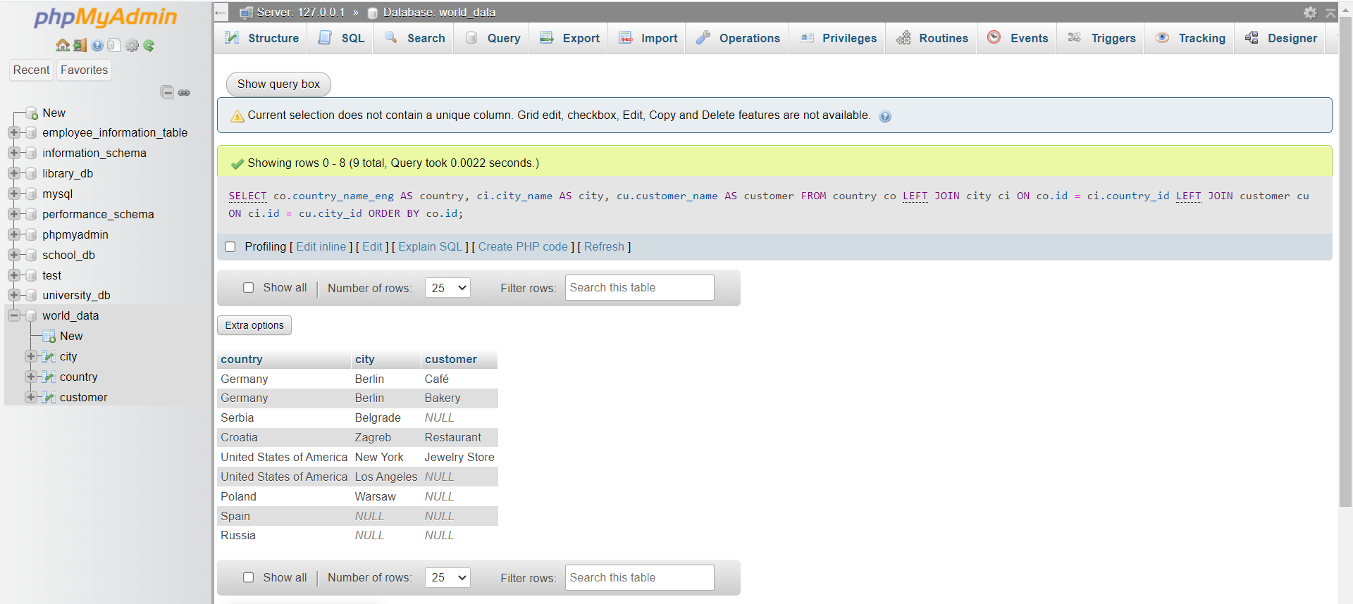

- Task 2: LEFT + INNER JOIN (Return only countries that have cities, and show their customers)

- Requirements:
- Return ONLY countries referenced by at least one city
- Exclude: Spain, Russia
- For each such country → show all city-customer pairs
Countries with no customers must still appear (Serbia, Los Angeles, Warsaw)

- Query: 2
SELECT
co.country_name_eng AS country,
ci.city_name AS city,
cu.customer_name AS customer
FROM country co
INNER JOIN city ci
ON co.id = ci.country_id
LEFT JOIN customer cu
ON ci.id = cu.city_id
ORDER BY co.id, ci.id;

